ML based pharmaceutical equipment cleanliness inspection

Snezhana Malkin

v 1.0, Jan 25, 2022

# 

Contents

Project Description 3

Review of the Existing Approaches 4

Method Used in this Project 4

Datasets 5

Data Collection 5

Data Annotation 6

Results 7

Object Detection - YOLOv7 7

Object Detection – Faster R-CNN 10

Mask R-CNN 12

Conclusions 14

Application 14

Appendix A: Results 17

YOLOv7 17

Faster R-CNN 17

Mask R-CNN 18

Appendix B: Resources 19

# Project Description

Product residues left on medical equipment can potentially harm patients who consume products produced on this equipment. Medical firms spend time and money to ensure that medical equipment is clean when product change is performed. Today cleaning verification process is completed by trained personnel. It is long, costly and does not guarantee that all residues will be identified therefore they often error on the side of “dirty” and perform extra cleaning.

Medical companies define permissible residue limits (PRL) for each product depending on permittable daily exposure to ingredients of this product. Most PRL produce visible residue, which can be identified by a trained technician.

Medical equipment typically made of stainless steel and exhibits two residue patterns: dotted and smeared.

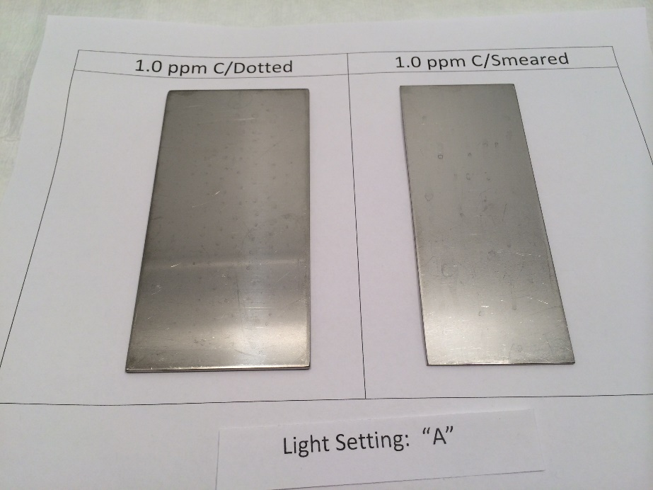

Picture 1: Samples from a human study showing stains on two stainless steel plates.

The goal of this project is to build ML system to identify residue based on pictures of the equipment and match or exceed human performance.

Table below shows results from a human study.

|  |  |  |  |  |
| --- | --- | --- | --- | --- |
| Active Ingredient Concentration | Training Level | Correct Identifications (TP+TN) | False Positives | False Negatives |
| High - 65 µg / 10 in sq | Trained | 98% | 2% | 0% |
| Medium - 6.5 µg / 10 in sq | Trained | 85% | 11% | 4% |
| Low - 0.65 µg / 10 in sq | Trained | 81% | 14% | 5% |
| High - 65 µg / 10 in sq | Untrained | 90% | 8% | 2% |
| Medium - 6.5 µg / 10 in sq | Untrained | 87% | 13% | 0% |
| Low - 0.65 µg / 10 in sq | Untrained | 82% | 16% | 2% |

Table1: Human performance baseline for three levels of active ingredient concentration.

# Review of the Existing Approaches

This task can be approached in multiple ways. We can formulate it as:

1. object detection task – detect areas containing residue;
2. object segmentation task – detect outlines of residues;
3. combination of object segmentation and volume measurement – detect outlines of residues and measure volume of residue.

For object detection state of the art implementations are based on YOLO [1]. There are successful applications of YOLO in weed detection in agriculture [2].

For object segmentation state of the art implementations are based on U-Net [3] or Mask R-CNN [4]. U-Net implementations are used for processing of chest CT to detect abnormalities caused by COVID-19 [5].

The ideal implementation would combine multiple models: one to solve object segmentation task and one to perform chemical composition and volume analysis. Practitioners in ML field in chemistry and agriculture discovered that hyperspectral images [<https://en.wikipedia.org/wiki/Hyperspectral_imaging>] provide information that can be used for chemical composition and volume analysis.

Most interesting work comes from Chinese researches using hyperspectral images to identify pesticide residue levels in grapes [6]. They compared application of Principal Component Analysis (PCA), Machine Learning (SVM, Linear Regression and Random Forest) and Deep Learning (CNN and ResNet) methods to identify levels of residues in grapes. They concluded that CNN and ResNet produce best results but results are hard to interpret. ML method are easier to interpret and provide minimal reduction in accuracy.

# Method Used in this Project

I would like to go through all methods described above, starting with object detection. I believe that all steps are important for the complete and comprehensive solution.

For object detection task, I used YOLO, Faster R-CNN and Mask R-CNN computer vision models and for object segmentation, I used Mask R-CNN.

1. YOLOv7 - <https://github.com/WongKinYiu/yolov7>
2. Faster R-CNN - <https://github.com/facebookresearch/detectron2/blob/main/configs/COCO-Detection/faster_rcnn_R_50_DC5_1x.yaml>
3. Mask R-CNN - <https://github.com/facebookresearch/detectron2/blob/main/configs/COCO-Detection/faster_rcnn_R_50_C4_1x.yaml>

All models were fine-tuned using weights pretrained on MS COCO dataset. Fine-tuned results exceed results for models trained from scratch due to limited size of my dataset.

For Faster R-CNN and Mask R-CNN, I used detectron2 libraries ([https://github.com/facebookresearch/detectron2](https://github.com/facebookresearch/detectron2%20)) provided by Meta Research (<https://github.com/facebookresearch>).

For Yolov7, I used implementation that was created as a branch of the original DarkNet YOLO implementation (<https://github.com/WongKinYiu/yolov7>).

I don’t have access to the equipment required to produce hyperspectral images. If first two steps are completed successfully, I will try to acquire a sponsor to get access to such equipment.

# Datasets

## Data Collection

There is no publicly available dataset for this project. I had to create it with some help from my chemist friend. She made solutions which were applied 0.05 µg / 100 cm sq in different pattens to a stainless-steel plate. Solution was allowed to dry for 2 hours and then each section was photographed under different light conditions and different angles/rotations using a Samsung phone. This simulates real conditions in which technician would take pictures.

Plates were re-used multiple times to create different patterns. Scratches were applied to plates to simulate wear of the equipment. Blanks were created to test detection when there is no residue.

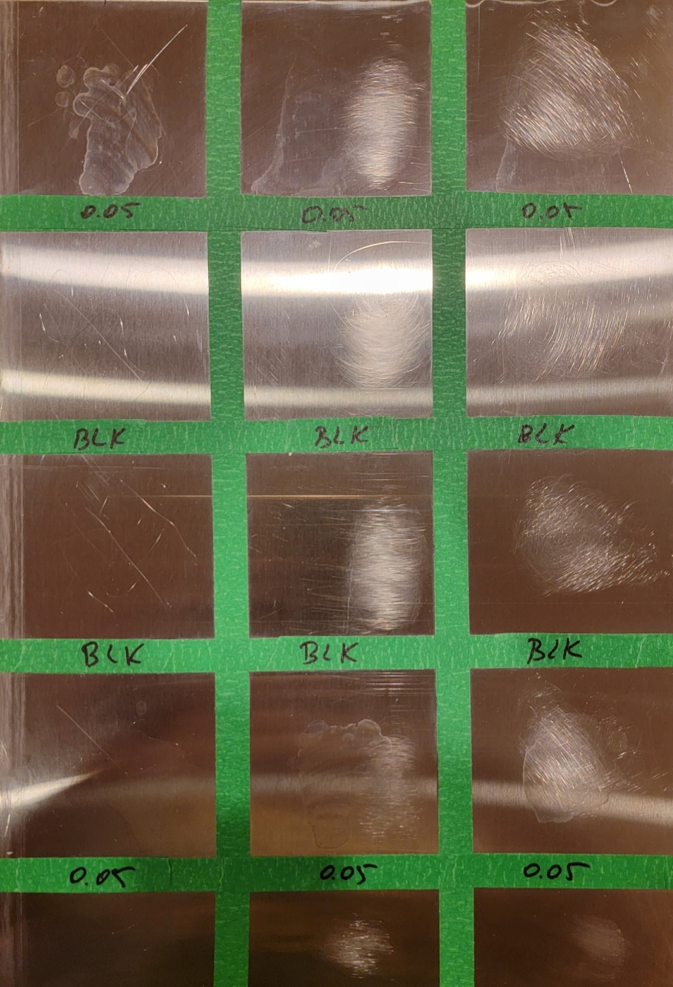

Picture 2: Picture of a plate with 3 samples of stains and 3 blanks.

Data set stats:

1. Number of training samples: 421 (all contain residues)
2. Number of validation samples: 29 (all contain residues)
3. Test set includes: 10 samples with residue and 10 samples with no residue (blanks)

## Data Annotation

For object detection, I needed to create bounding boxes for all mages in the training and validation datasets.

I used Make Sense (<https://www.makesense.ai/)> tool to create ground truths. Number of boxes per image ranges from 1 to 20.

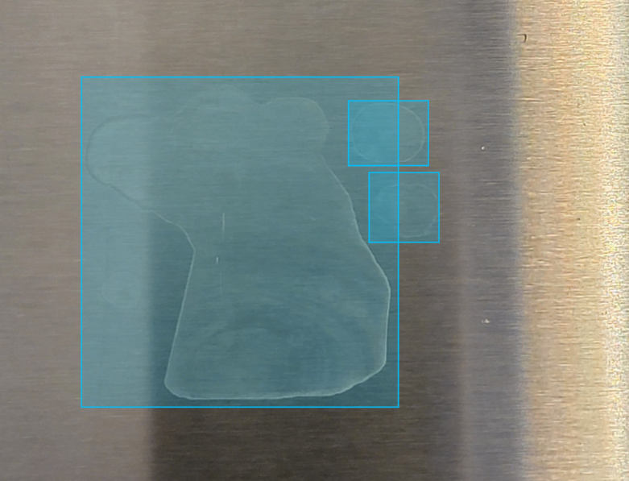

Picture 3: Sample with 3 bounding boxes.

For object segmentation, I used labelme open-source tool (<http://labelme.csail.mit.edu/Release3.0/)> which allows to create both masks and bounding boxes. Then labeled images were converted to COCO format dataset using labelme2coco conversion program (<https://github.com/Tony607/labelme2coco>).

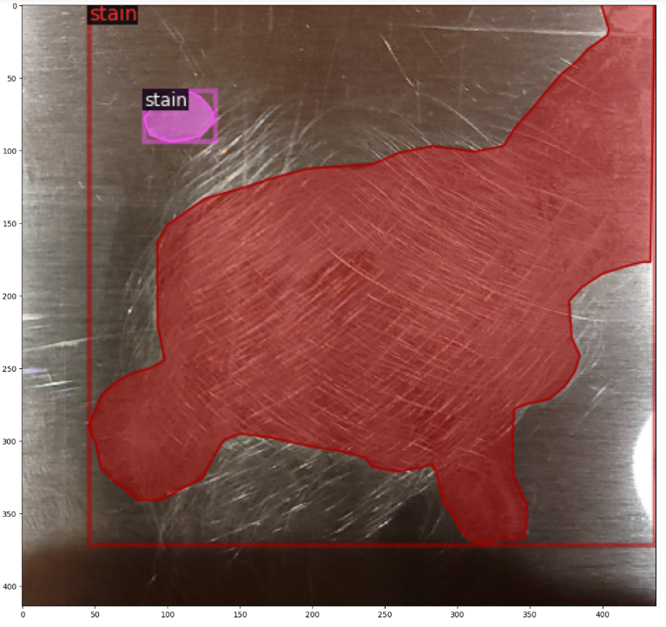

Picture 3: Sample with 2 stain masks and 2 bounding boxes.

# Results

## Object Detection - YOLOv7

I tried different parameters (including training this model from scratch) and the best results were achieved with fine-tuning on 160 epochs. With longer training, this model starts to overfit.

Training data stats:

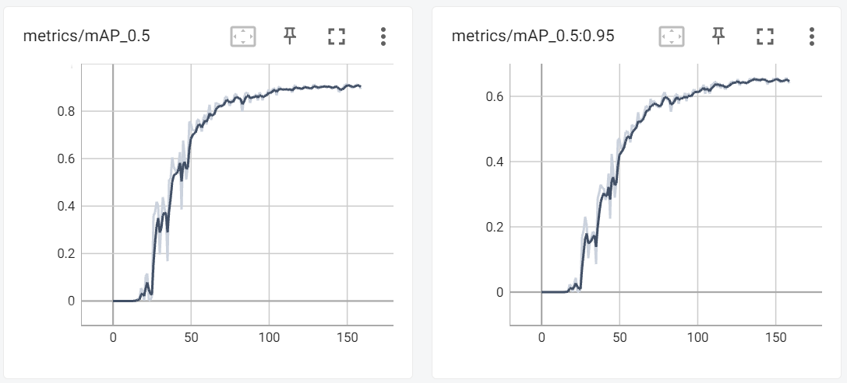

Picture 4: mAP stats at different confidence levels

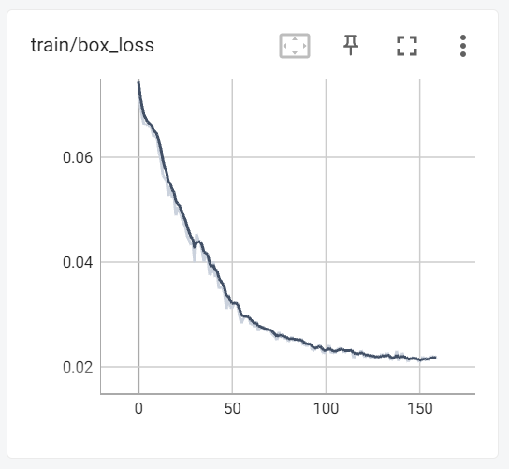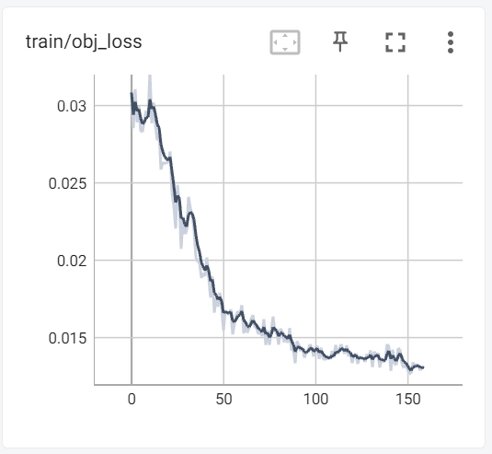

Picture 5: Training loss

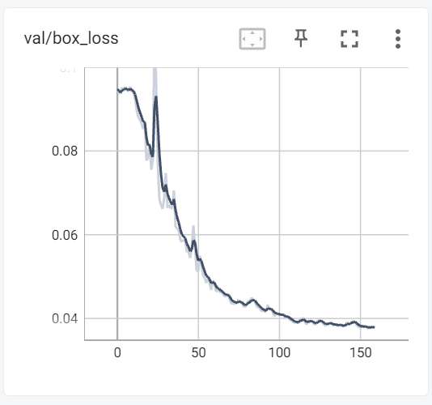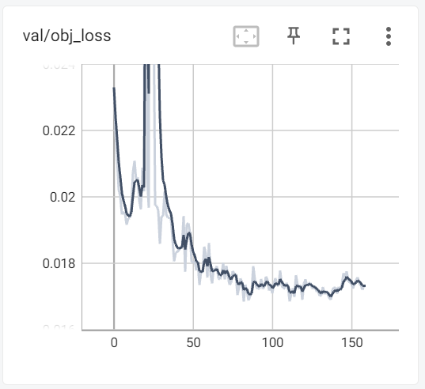

Picture 6: Validation loss

The box loss is improving with training (see picture 5 and 6). This metric is less important for this particular business task. Even if box has a partial object coverage, it is still a good result.

The most important metric for this business task is object loss, which shows how well model identified class stan vs. background. This metric is not improving with more training (picture 6). Actually, it is getting worse which points to overfitting of the model.

Another important metric for this task is confusion matrix. Having False Positive (FP) is less critical for the business than having False Negatives (FN). FN represent a dangerous condition where a stain is not identified and next product could potentially be contaminated. FP will trigger an extra cleaning cycle which not as bad as contaminated product.

Based on charts (see Picture 4) for mAP (mean Average Precision), we can call it AP because we have only one class, we get best results at low confidence (0.5) level. At higher confidence levels (0.5-0.95), we barely get over 0.6 precision. Based on this info, I chose 0.5 confidence level for detection on test data.

To compare all models, I used the same test data set and manually calculated confusion matrix using the following rules:

1. TP – number of individual stains correctly identified in the image regardless of IOU.
2. TN – set to 1 to mark correctly identified background; set to 0 if the entire image is covered by a bounding box.
3. FP – number of bounding boxes which cover areas with no stain; partial coverage counted as TP.
4. FN – Number of missing bounding boxes as compared to ground truth.

See Appendix A for samples of calculations.

The test data set as described above, consists of 10 images with stains and 10 images without stains (blanks). Blanks represent a more typical scenario in real life than stained areas.

For the 10 images with stains, we have the following number of ground truth boxes: 4, 3, 5, 9, 3, 6, 1, 3, 5, 2. Total 41 ground truth boxes. And 0 ground truth boxes for 10 blanks.

|  |  |  |
| --- | --- | --- |
| Predicted/Actual | True | False |
| True | TP – 20 (31.7%) | FP – 2 (3.3%) |
| False | FN – 21 (33.3%) | TN – 20 (31.7%) |

In order to compare the model performance with humans, we need to calculate another metric. Humans were asked to separate all plates into two piles: clean and dirty. This means that humans can say that a plate is dirty if they see one stain. They were not asked to identify all stains.

If we use this approach then, we need to use the following rules:

1. TP – number of images with stains where at least one stain is identified correctly.
2. TN – number of blanks where no stains were identified.
3. FP – number of blanks where at least one stain was identified.
4. FN - number of images with stains where no stains were identified.

|  |  |  |
| --- | --- | --- |
| Predicted/Actual | True | False |
| True | TP – 10 (50%) | FP – 1 (5%) |
| False | FN – 0 (0%) | TN – 9 (45%) |

Now we can compare human performance with YOLOv7 performance.

|  |  |  |  |  |
| --- | --- | --- | --- | --- |
| Active Ingredient Concentration | Training Level | Correct Identifications (TP+TN) | False Positives | False Negatives |
| Low - 0.65 µg / 10 in sq | Human Trained | 81% | 14% | 5% |
| Low - 0.65 µg / 10 in sq | Human Untrained | 82% | 16% | 2% |
|  |  |  |  |  |
| Low - 0.05 µg / 100 cm sq | YOLOv7 at confidence level 0.5 based on plates identification | 95% | 1% | 0% |
| Low - 0.05 µg / 100 cm sq | YOLOv7 at confidence level 0.5 based on individual stain identification | 63.4% | 3.3% | 33.3% |

If we look at how well this model identifies dirty plates, it beats human performance. But if we look at how well this model identifies each individual stain then its performance is not impressive because it misses 33% of stains.

## Object Detection – Faster R-CNN

Results of fine-tuning Faster R-CNN model pretrained on MS COCO dataset for 3,000 epochs.

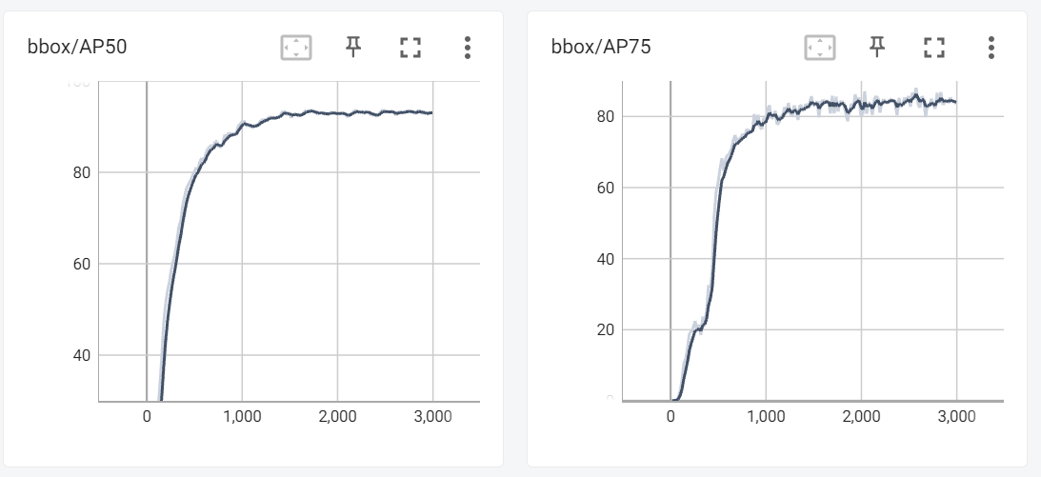

Picture 7: Average Precision (AP) results for 50 and 75 confidence levels.

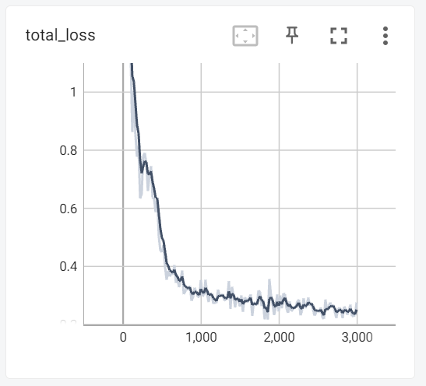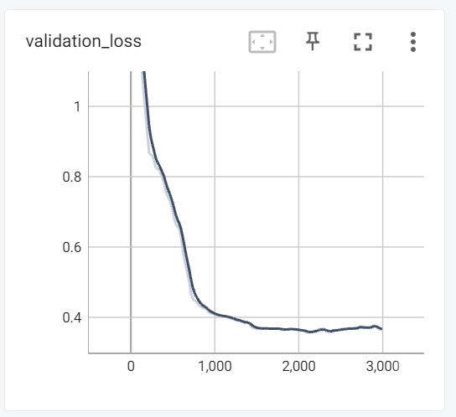

Picture 8: Training and validation loss

I chose long training cycle (3,000 epochs) for this model because it shows improvement in training loss but validation loss stops improving (see picture 8) therefore training for more epochs would not deliver a better result.

At 50% confidence level this model reaches 93% accuracy (see picture 7). I chose 75% level for detection on test dataset. This setting reduces number of False Positives.

I used the same rules as described in the previous section to calculate confusion matrix for bounding boxes.

|  |  |  |
| --- | --- | --- |
| Predicted/Actual | True | False |
| True | TP – 39 (57.3%) | FP – 7 (10.2%) |
| False | FN – 2 (3.1%) | TN – 20 (29.4%) |

I used the same rules as described in the previous section to calculate confusion matrix for plates.

|  |  |  |
| --- | --- | --- |
| Predicted/Actual | True | False |
| True | TP – 10 (50%) | FP – 4 (20%) |
| False | FN – 0 (0%) | TN – 6 (30%) |

Now we can compare human performance with Faster R-CNN performance.

|  |  |  |  |  |
| --- | --- | --- | --- | --- |
| Active Ingredient Concentration | Training Level | Correct Identifications (TP+TN) | False Positives | False Negatives |
| Low - 0.65 µg / 10 in sq | Human Trained | 81% | 14% | 5% |
| Low - 0.65 µg / 10 in sq | Human Untrained | 82% | 16% | 2% |
|  |  |  |  |  |
| Low - 0.05 µg / 100 cm sq | Faster R-CNN at confidence level 0.75 based on plates identification | 80% | 20% | 0% |
| Low - 0.05 µg / 100 cm sq | Faster R-CNN at confidence level 0.75 based on individual stain identification | 86.7% | 10.2% | 3.1% |

Faster R-CNN performs close to humans and it does it on per object basis not per plate basis.

## Mask R-CNN

Results of fine-tuning Mask R-CNN model pretrained on MS COCO dataset for 3,000 epochs.

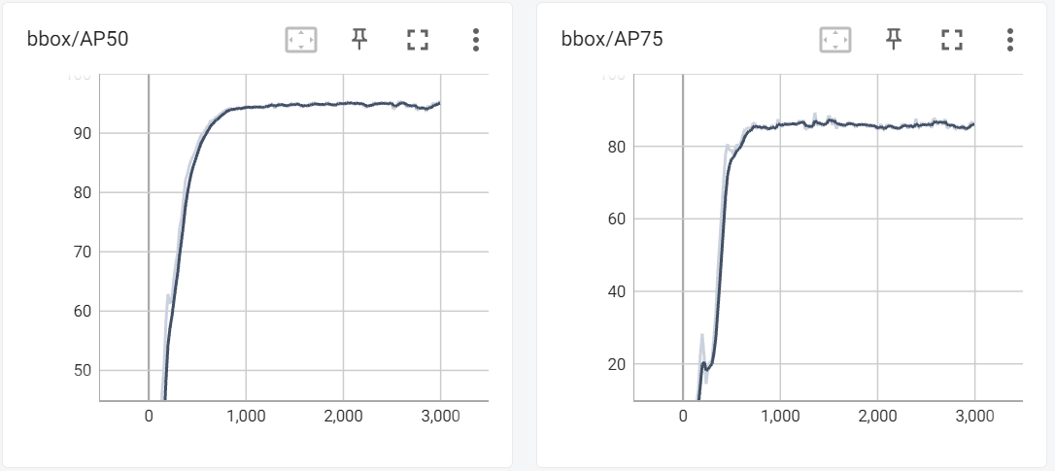

Picture 9: Training stats for AP50 and AP75

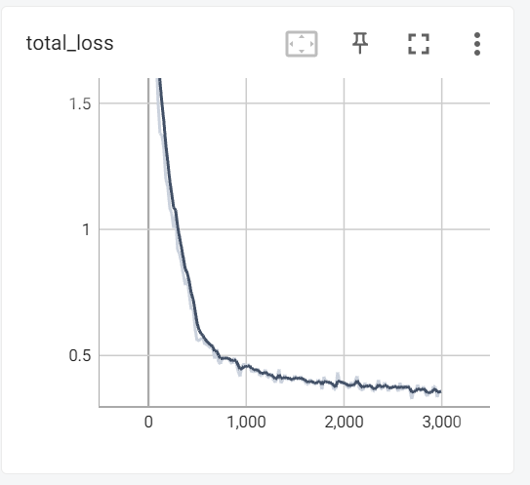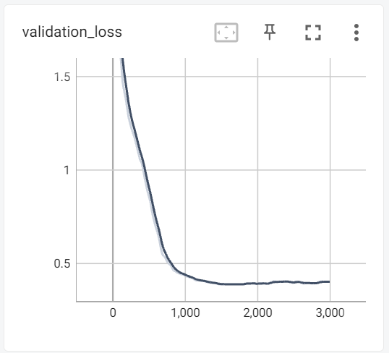

Picture 10: Training and validation loss

I chose long training cycle (3,000 epochs) for this model because it shows improvement in training loss but validation loss stops improving (see picture 10) therefore training for more epochs would not deliver a better result.

At 50% confidence level this model reaches 95% accuracy (see picture 9). I chose 75% level for detection on test dataset. This setting reduces number of False Positives.

I used the same rules as described in the previous section to calculate confusion matrix for bounding boxes.

|  |  |  |
| --- | --- | --- |
| Predicted/Actual | True | False |
| True | TP – 37 (50%) | FP – 13 (17.5%) |
| False | FN – 4 (5.5%) | TN – 20 (27%) |

I used the same rules as described in the previous section to calculate confusion matrix for plates.

|  |  |  |
| --- | --- | --- |
| Predicted/Actual | True | False |
| True | TP – 10 (50%) | FP – 5 (25%) |
| False | FN – 0 (0%) | TN – 5 (25%) |

Now we can compare human performance with Faster R-CNN performance.

|  |  |  |  |  |
| --- | --- | --- | --- | --- |
| Active Ingredient Concentration | Training Level | Correct Identifications (TP+TN) | False Positives | False Negatives |
| Low - 0.65 µg / 10 in sq | Human Trained | 81% | 14% | 5% |
| Low - 0.65 µg / 10 in sq | Human Untrained | 82% | 16% | 2% |
|  |  |  |  |  |
| Low - 0.05 µg / 100 cm sq | Mask R-CNN at confidence level 0.75 based on plates identification | 75% | 25% | 0% |
| Low - 0.05 µg / 100 cm sq | Mask R-CNN at confidence level 0.75 based on individual stain identification | 77% | 17.5% | 5.5% |

Mask R-CNN performs below human performance on both per plate and per object metrics.

# Conclusions

Yolov7 beats human performance on per plate basis and Faster R-CNN comes close to human performance on per object basis. Per plate basis is not a reliable indicator of performance. I only calculated it to match human experiments.

These results are encouraging because concentrations we used are actually smaller than what was used in human studies. We also used pictures unlike humans who were looking at actual plates and could move them around to find the best angle to see stains. Based on pictures, angle makes a big difference in successful detection of stains. In realistic environment equipment can’t be moved to find the best angle to see stains.

Also processing pictures, which include results of detection, is a better practice because it includes documentation for decisions made.

# Application

I wrote an application which would allow technicians to use two (Faster R-CNN and YOLOv7) out of three models to help with stain detection. I picked two models because it provides more information to a technician to make the final decision.

Faster R-CNN is the best model according to statistics calculated on the test data but it errors on the side of dirty. It frequently finds dirt on blank plates. YOLOV7 is the second-best model according to statistics calculated on the test data. It shows the opposite bias to the Faster R-CNN. It marks clean plates as clean but can miss some stain on dirty plates. Combination of both models gives sufficient information for a human to make the final decision.

The application is built in a docker container and can be downloaded from Docker Hub using command: docker run -p 5000:5000 susanmalkin/sm_final:latest.

When downloaded, this container will start Flask application on the port 5000. To use the application, connect from your browser to the machine which runs docker container on port 5000. If you run docker on the same machine as the browser, use this command: <http://localhost:5000/> to access this application.

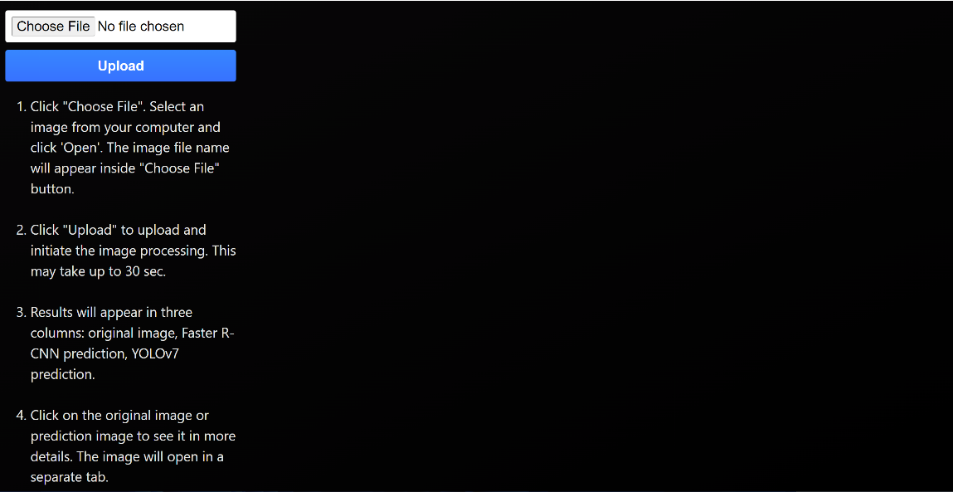

Picture 11: Initial screen of the application

You can upload images from your computer using “Choose File” button followed by “Upload” button.

When a new image file is uploaded, the application will calculate predictions using Faster R-CNN and YOLOv7 models and display them side-by-side with the uploaded image.

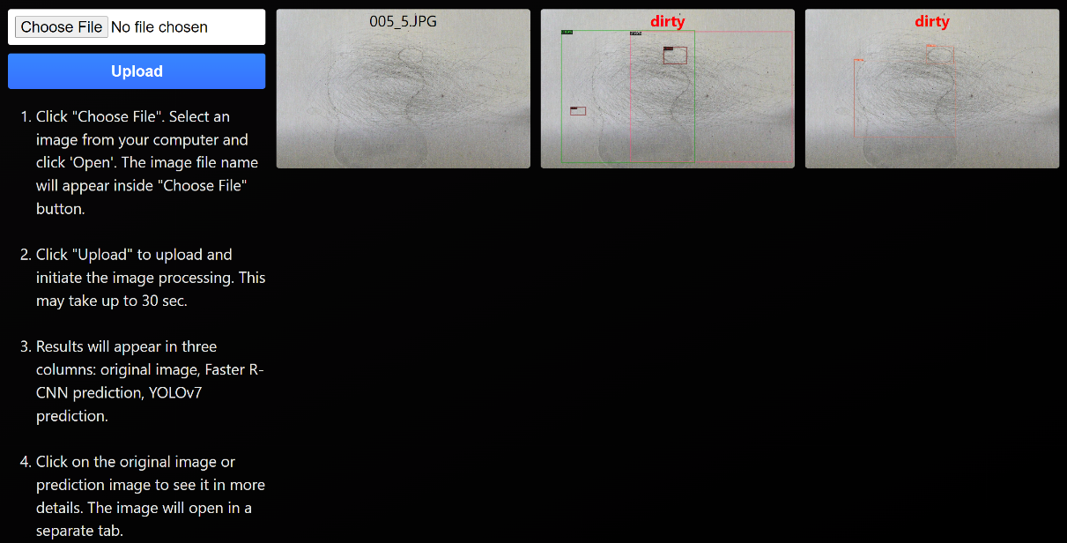

Picture 12: One uploaded image processed

The application will mark all found stains using bounded boxes with confidence score. A technician can click on each image to examine it in more details.

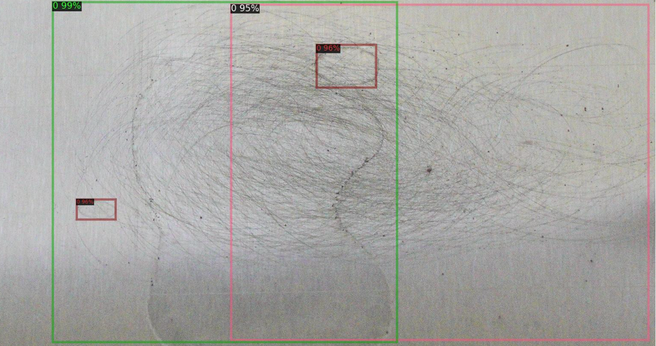

Picture 13: Full display of a prediction image

Multiple images can be uploaded and examined. Models can give different prediction in terms of the final answer (clean/dirty) for some images (see row two in the image below) but most of the time they provide the same answer.

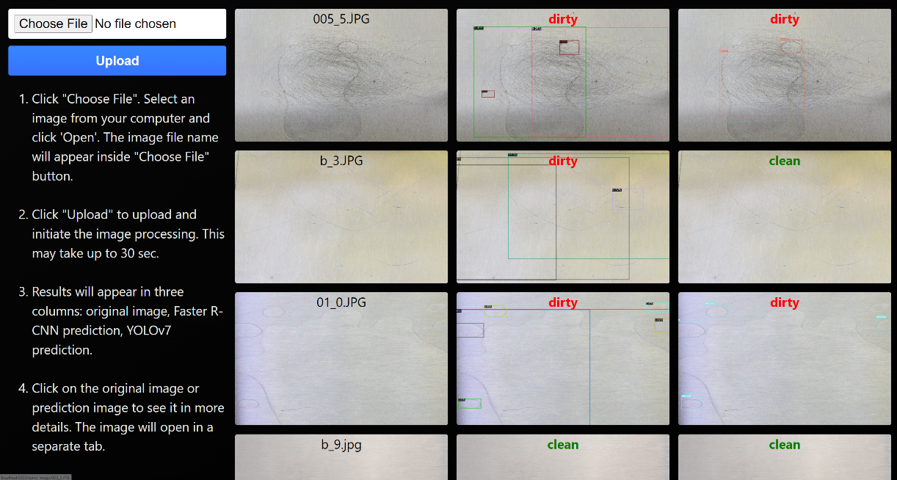

Picture 14: Multiple images with predictions

This application will save time and improve quality of stain detection for medical equipment. It will reduce reliance on technician’s eyesight and diligence, and provide good documentation for the decisions made by technicians. The similar approach is used in many industries where ML systems process images and then humans make final decision based on their expertise and data provided by the ML system.

# Appendix A: Results

## YOLOv7

Samples of confusion matrix calculations based on predicted boxed vs. ground truth for the test dataset.

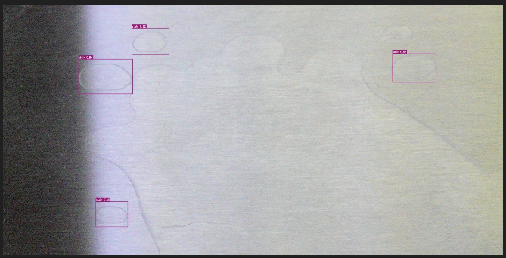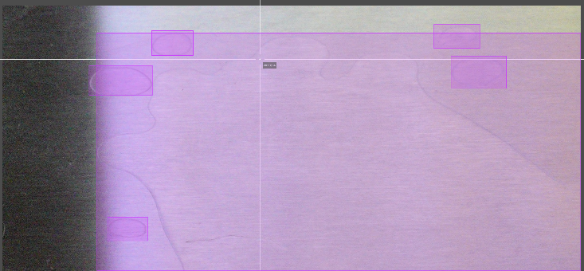

TP:4, TN:1, FP:0, FN: 2

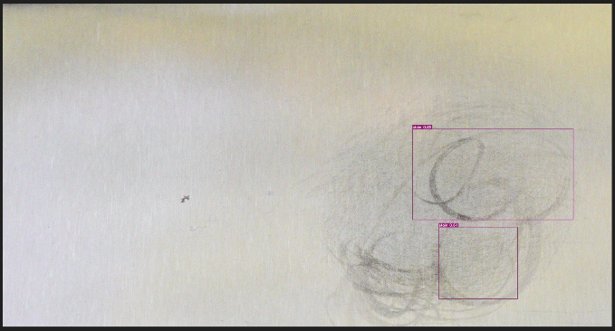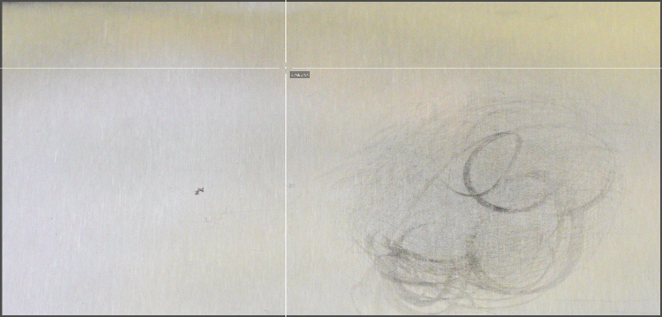

TP:0, TN:1, FP:2, FN: 0

## Faster R-CNN

Samples of confusion matrix calculations based on predicted boxed vs. ground truth for the test dataset.

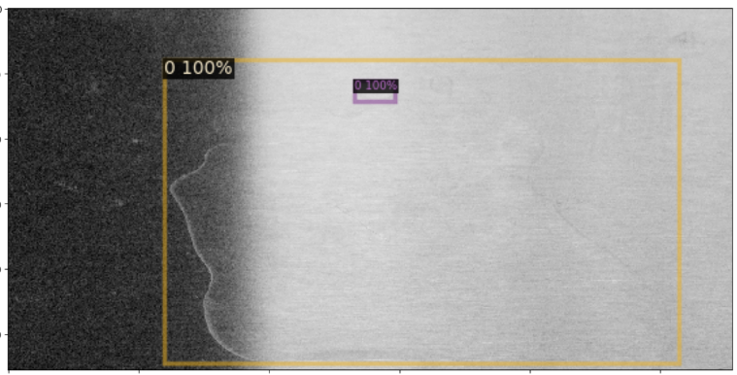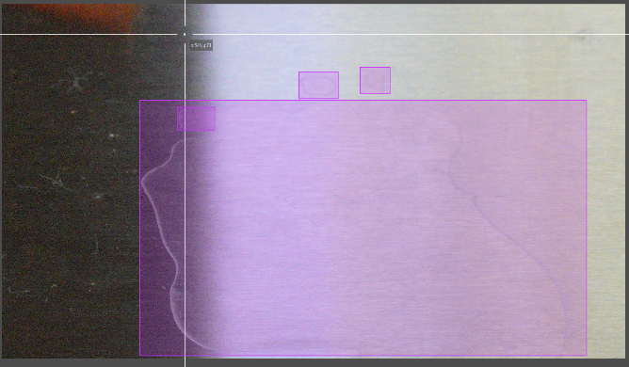

TP:2, TN:1, FP:0, FN: 2

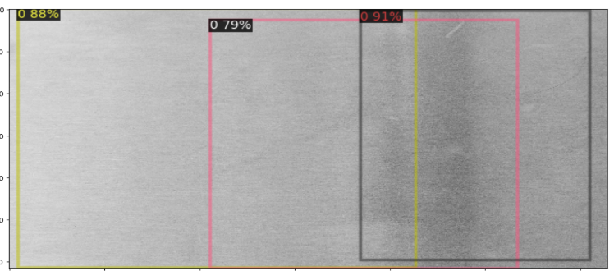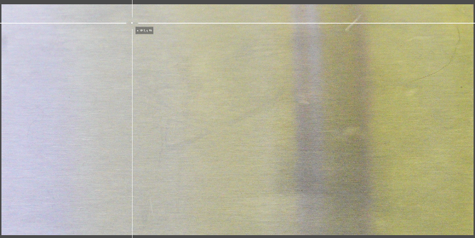

TP:0, TN:1, FP:3, FN: 0

## Mask R-CNN

Samples of confusion matrix calculations based on predicted boxed vs. ground truth for the test dataset.

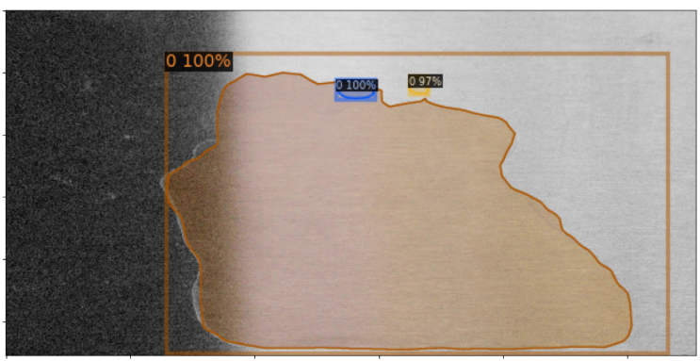

TP:3, TN:1, FP:0, FN: 1

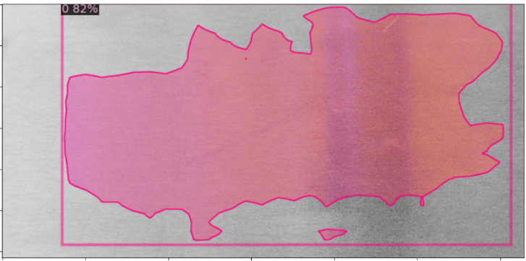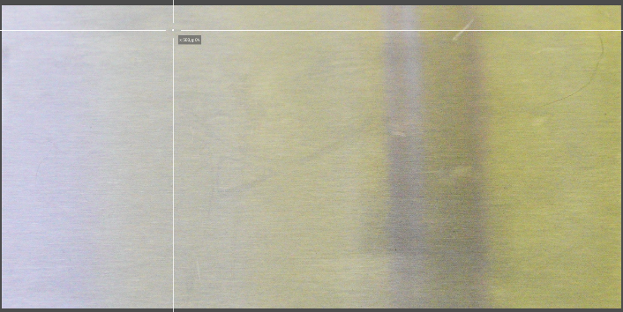

TP:0, TN:1, FP:1, FN: 0

# Appendix B: Resources

[1] You Only Look Once: Unified, Real-Time Object Detection. Joseph Redmon, Santosh Divvala, Ross Girshick, Ali Farhadi. <https://arxiv.org/pdf/1506.02640.pdf>

[2] An Aerial Weed Detection System for Green Onion Crops Using the You Only Look Once (YOLOv3) Deep Learning Algorithm. Addie Ira Borja PARICO, Tofael AHAMED. <https://www.jstage.jst.go.jp/article/eaef/13/2/13_42/_pdf/-char/en>

[3] U-Net: Convolutional Networks for Biomedical Image Segmentation. Olaf Ronneberger, Philipp Fischer, and Thomas Brox. <https://arxiv.org/pdf/1505.04597.pdf>

[4] Mask R-CNN. Kaiming He Georgia Gkioxari Piotr Dollar Ross Girshick. <https://arxiv.org/pdf/1703.06870.pdf>

[5] Rapid AI Development Cycle for the Coronavirus (COVID-19) Pandemic: Initial Results for Automated Detection & Patient Monitoring using Deep Learning CT Image Analysis. Ophir Gozes , Ma’ayan Frid-Adar, Hayit Greenspan, Patrick D. Browning, Huangqi Zhang, Wenbin Ji, Adam Bernheim, and Eliot Siegel. <https://arxiv.org/ftp/arxiv/papers/2003/2003.05037.pdf>

[6] Detection of Pesticide Residue Level in Grape Using Hyperspectral Imaging with Machine Learning. [Weixin Ye](https://sciprofiles.com/profile/2245717), [Tianying Yan](https://sciprofiles.com/profile/894503), [Chu Zhang](https://sciprofiles.com/profile/213047), [Long Duan](https://sciprofiles.com/profile/author/dG1MeTZGUnhKWTBDVkdLaVBBR2gyczgvS051SEtGTndTWGtnTnByWU9WUT0=), [Wei Chen](https://sciprofiles.com/profile/author/WUxmalRWK2MxcGtHVGg3WFhSZ09aYmtGWVdtZW1WTkMwVE9pVndSRVBWYz0=), [Hao Song](https://sciprofiles.com/profile/author/TmpSSFhkRzBWaWppU3h1Vk1nc1JDUng2QWFZTEo0c0xpWldGYzVHd3VsTT0=), [Yifan Zhang](https://sciprofiles.com/profile/author/b3BzZjVOZkhuTjFuNlRGNXNET055Ymd6NHRUVUJhcUR6VElyRzJyRk5DND0=), [Wei Xu](https://sciprofiles.com/profile/2211776) [Pan Gao](https://sciprofiles.com/profile/537025). <https://www.mdpi.com/2304-8158/11/11/1609>